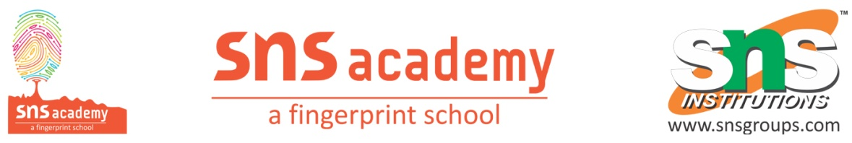
CLASS TEST
GRADE – XII MARK - 20
SUBJECT – CHEMISTRY TIME – 40 MINS
1. Explain a chemical test to distinguish between primary, secondary and tertiary alcohols.
2. How to convert
(a) Ethanal to propan -2- ol
(b) l – propanol to 2 – bromo propane
(c) Ethanol to propanone
3. Show how are the following alcohols prepared by the reaction of a suitable grignard reagent on methanal?
4. Predict the major product of acid catalysed dehydration of
(i) 1-Methylcyclohexanol and (ii) Butan-1-ol
5. Explain why propanol has higher boiling point than that of the hydrocarbon, butane?
6. Alcohols are comparatively more soluble in water than hydrocarbons of comparable molecular masses. Explain this fact.
7. Explain how does the -OH group attached to a carbon of benzene ring activate it towards electrophilic substitution?
8. Give reason for the higher boiling point of ethanol in comparison to methoxymethane.
9. Convert butanol to butanoic acid
10. Write the mechanism for dehydration of alcohols

